TEACHER: MWALE CHIPO

DESIGN AND TECHNOLOGY DEPARTMENT
LESSON PLAN

SUBJECT: DESIGN AND TECHNOLOGY CLASS:…… … DATE:……/……./20…. DURATION:………….
BOYS:…………………… GIRLS ………………………………………. TOTAL OF PUPILS… TOPIC: SYSTEM TECHNOLOGY SUBTOPIC: STRUCTURE LEARNING OUTCOMES LSBAT

Define structure
- Identify and explain types of structures
- State and explain groups of structure
RATIONALE
Knowledge: Natural, Artificial (Man-Made), Mass, Frame and Shell Structures
Skills: Identification, design, Values: Problem solving, Team work TEACHING AIDS: Ladder , egg shell, tree, e.t.c
PART | LESSON CONTENT | METHOD OLOGY | LEARNER ACTIVITY
Introd uction | - Recap on the previous lesson | Questions and answers | Provide answers
Develo pment | SYSTEM TECHNOLOGY  STRUCTURE  - Structure is anything that can support a load or weight or anything.  - The load may be an object or a person.  TYPES OF STRUCTURES  - NATURAL STRUCTURE  - Structures not made by people.  - Examples: feathers, sand dune, tree, skeleton, egg shell, spider webs, caves, birds feather  - ARTIFICIAL (MAN-MADE)  - Structures that have been built by people.  - Examples: buildings, umbrellas, jigsaw puzzle, human house, bridges, shopping bags, pylon  THREE GROUPS OF STRUCTURES  MASS STRUCTURE  - Structure can be made by piling up or forming similar materials into a particular shape or design.  - Examples: mountains, bricks walls FRAME STRUCTURES  - Structures have a skeleton of very strong materials, which supports the weight of the roof and covering materials.  - Simple frame consist only of a frame and some frame structures are more complex with added parts.  - Examples: Ladders, spider webs, bicycles, umbrellas, human house, water tank support, pylons. Skeleton  SHELL STRUCTURES  - A shell structure gains its strength from the shape and its one piece structure.  - A shell provides support from the outside  - Example: egg shell, bottle, pipe, clay pot.
Applicatio n | CLASS EXERCISE  - Define structure  - Explain two types of structures  - State and explain groups of structure  - Refer to self-testing question 7.5 (G9 page 30) | Questions And Answers | Provide answers
Concl usion | - Recap on the main steps and points | V/E

LESSON EVALUATION

KENNETH KAUNDA SECONDARY SCHOOL

TEACHER; MWALE CHIPO
DESIGN AND TECHNOLOGY DEPARTMENT LESSON PLAN

SUBJECT: DESIGN AND TECHNOLOGY CLASS:…… … DATE:……/……./20…. DURATION:………….
BOYS:…………………… GIRLS ………………………………………. TOTAL OF PUPILS…
TOPIC: SYSTEM TECHNOLOGY SUBTOPIC: TYPES OF FORCES IN STRUCTURE
LEARNING OUTCOMES LSBAT
- Explain types of forces acting on the structure
- State causes of structural failure
- Explain how to Stabilising a Structures
RATIONALE
Knowledge: Types of Forces in Structure (Struts and Ties)
Skills: Identification, design,
Values: Problem solving, Team work
TEACHING AIDS:
PART | LESSON CONTENT | METHOD OLOGY | LEARNER ACTIVITY
Introd uction | - Recap on the previous lesson | Q/A | Provide answers
Develo pment | STRUCTURE  TYPES OF FORCES IN STRUCTURE  SUPPORTING A LOAD  - A structure must be able to support its own weight and the load it has to carry.  - A moving load is known as Dynamic load  - A stationary load is known as static STRUTS AND TIES  - Compression members in trusses are called struts (B)  - Tension members in trusses are called ties (A)  EXAMPLES  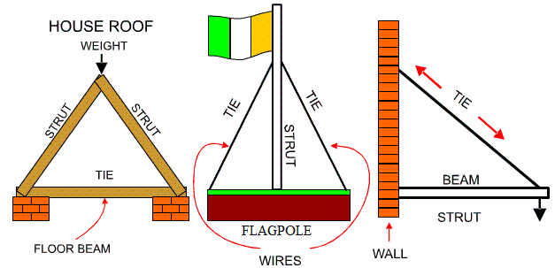  CAUSES OF STRUCTURAL FAILURE  - Poor design  - Over loading/fatigue  - Poor joints or material  - Forces acting on them. These can be:  - Stationary force (static) due to structures own weight  - Dynamics forces (moving forces)  STABILISING STRUCTURES  Structure can be strengthened by:  - Making the base heavier  - Making the base wider  - Triangulation: triangle is the strongest form of a structure TRUSSES DESIGN USING TRIANGULATION METHOD NOTE  - Triangulation is important in a truss because it evenly distributes the load
Applic ation | CLASS EXERCISE  - Explain types of forces acting on the structure  - State causes of structural failure  - Explain how to Stabilising a Structures  - Refer to self-testing question 7.6(G9 page 34) | Questions And Answers | Provide answers
Conclu sion | - Recap on the main steps and points | V/E

TEACHE:M
DESIGN AND TECHNOLOGY DEPARTMENT
LESSON PLAN

SUBJECT: DESIGN AND TECHNOLOGY CLASS:…… … DATE:……/……./20…. DURATION:………….
BOYS:…………………… GIRLS ………………………………………. TOTAL OF PUPILS…
TOPIC: SYSTEM TECHNOLOGY SUBTOPIC: MOMENT OF A FORCE
LEARNING OUTCOMES LSBAT
- Define moment of a force?
- Explain principle of moments
- Calculate the moment of a force.
RATIONALE
Knowledge: Moment of A Force, Principle of moments
Skills: Identification, design,
Values: Problem solving, Team work
TEACHING AIDS:
PART | LESSON CONTENT | METHOD OLOGY | LEARNER ACTIVITY
Introd uction | - Recap on the previous lesson | Q/A | Provide answers
Develo pment | SYSTEM TECHNOLOGY  MOMENT OF A FORCE  - The turning effect produced by force acting on the body.  - It is equal to the product of the force and the perpendicular distance from its line of action to the point, or pivot, about which the body turns  FORMULA OF MOMENT OF FORCE  Moment of force = Force (N) x Distance (m)  - Where the perpendicular distance is d metre and magnitude of the force is F newton  - The units is Newton metre (Nm)  PRINCIPLE OF MOMENTS  - States that, when an object is in equilibrium, the sum of anticlockwise moments about any point equals the sum of clockwise moments about the same point.  - Clockwise moments = anticlockwise moment  EXAMPLE 1  Consider the diagram below, whereby a plank is supported by a pivot. Two forces, 120 N and F are acting on the plank.  - Calculate fore F  - State whether its balanced or not  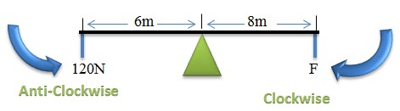  SOLUTION  Clockwise moments = anticlockwise moment Distance x Force = Distance x Force  8 x F = 120 x 6 = 8F= 720 F = 720/8 = 90N  Therefore Clockwise moments = anticlockwise moment  8 x 90 = 120 x 6 . 720Nm = 720Nm Balanced
Application | CLASS EXERCISE  - Define moment of a force?  - Explain principle of moments.  - Refer to the diagram Find m? (Ans= 12m)  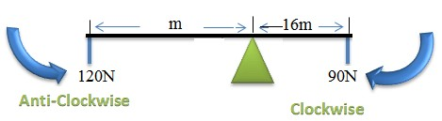 | Questions And Answers | Provide answers
Conclu sion | - Recap on the main steps and points | V/E

TEACHER: MWALE CHIPO

DESIGN AND TECHNOLOGY DEPARTMENT
LESSON PLAN

SUBJECT: DESIGN AND TECHNOLOGY CLASS:…… … DATE:……/……./20…. DURATION:………….
BOYS:…………………… GIRLS ………………………………………. TOTAL OF PUPILS…
TOPIC: MECHANISMS SUBTOPIC: MOTION
LEARNING OUTCOMES LSBAT
- Define mechanisms
- Mention what is involved in mechanisms
- Explain function of mechanism
- Identify and explain types of motions
RATIONALE
Knowledge: Types of Motions

Skills: Identification, Design, Drawing Interpretation
Values: Problem Solving, Team Work
TEACHING AIDS
……………………………………………………………………………………………………………………………………………

PART | LESSON CONTENT | METHOD OLOGY | LEARNER ACTIVITY
Introd uction | - Recap on the previous lesson | Questions and answers | Provide answers
Development | MECHANISMS  Mechanism is something that changes input motion and force into output motion and force  All mechanisms  - Involve some kind of motion  - Involve some kind of force  - Makes a job easier to do  - Need some kind of input to make them work  - Produce some kind of output  FUNCTION MECHANISMS  - Provide the energy to do the work  - Make a job easier to do  MOTION  TYPES/ FORMS OF MOTION  - Linear Motion is movement in the straight line. Example of a knife cutting through a loaf of bread  - Rotary Motion. This is turning in a circle. Example hands of a clock Fan moving in the house    - Oscillating Motion. The swinging of forward and backward in an arc of a circle. Example the pendulum,  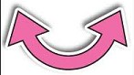  - Reciprocating Motion. This is forwards and backwards movement in a straight line. Example piston in a car
Applic ation | CLASS EXERCISE  - Explain the following  - Linear motion , Rotary motion , Reciprocating motion  - Define mechanisms  - Explain the functions of mechanism | Questions And Answers | Provide answers
Concl usion | - Recap on the main steps and points | V/E

TEACHER: MWALE CHI
DESIGN AND TECHNOLOGY DEPARTMENT
LESSON PLAN

SUBJECT: DESIGN AND TECHNOLOGY CLASS:…… … DATE:……/……./20…. DURATION:………….
BOYS:…………………… GIRLS ………………………………………. TOTAL OF PUPILS… TOPIC: MECHANISMS SUBTOPIC: FORCE
LEARNING OUTCOMES LSBAT
- Define force
- Identify and explain types of forces
RATIONALE
Knowledge: Types of Forces,
Skills: Identification, Design, Drawing Interpretation
Values: Problem Solving, Team Work
TEACHING AIDS
PART | LESSON CONTENT | METHOD OLOGY | LEARNER ACTIVITY
Introd uction | - Recap on the previous lesson | Questions and answers | Provide answers
Development | FORCE  - Forces are stresses such as pushes or pulls  - A standard unit of force is called a Newton (N). TYPES OF FORCES  - STATIC FORCE. a force which is stationary e.g someone standing on a beam or a bridge.  - DYNAMIC Force Is a moving force when a static person on a bridge starts jumping, the force applied is more than the one standing.  - TENSION FORCE: It is a pulling force. It forces the member to stretch    - COMPRESSION FORCE. Force which will cause a member to be squashed or pushed  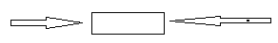  - SHEAR Force Shear is a cutting force e.g a pair of scissors exerts a shear force between its two blades in order to cut a piece of paper/material  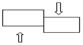  - BENDING FORCE; A force which tends to make a structure bend e.g. a beam which is flat over a long span with a load will tend to bend  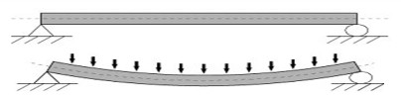  - TORSION FORCES which turn or twist a structure. Example a spanner turning a nut to lock it into place. Wringing of clothes by hand:  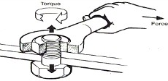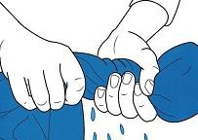  FORCES ACTING ON THE BEAM  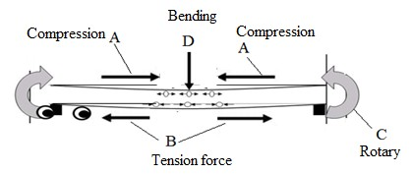
Appli cation | CLASS EXERCISE  - With the aid of the diagram explain the following forces  - Static force ,Dynamic force , Compression force , Tension force | Questions And Answers | Provide answers
Conclu sion | - Recap on the main steps and points | V/E

TOPIC: MECHANISMS SUBTOPIC: MECHANICAL ADVANTAGE, FFICIENCY, AND VELOCITY RATIO
LEARNING OUTCOMES LSBAT
- Explain the following: Mechanical advantage, Velocity Ratio, Efficiency
- Calculate Mechanical advantage, Velocity Ratio, Efficiency
RATIONALE

Knowledge: Mechanical advantage, Velocity Ratio, Efficiency
Skills: Identification,
Values: Problem Solving, Team Work
TEACHING AIDS
PART | LESSON CONTENT | METHOD OLOGY | LEARNER ACTIVITY
Introd uction | - Recap on the previous lesson | Questions and answers | Provide answers
Development | MECHANISMS  MECHANICAL ADVANTAGE (MA)  - Refers to the force needed to move a load divided by the resistance force that the load exerts, such as its weight.  - The ratio of resistance overcomes to the effort applied.  MA = load  Effort  VELOCITY RATIO (V.R)  - V.R is the comparison of the distance a load moves to the distance travelled by the force needed to move it.  - The ratio of distance travelled by effort to the distance travelled by load in the machine.  V.R = Distance moved by the effort Distance moved by the load  EFFICIENCY  - The ratio of useful output to total input.  Efficiency = Output x 100% =Work outx 100%=MA 𝑥 100%  Input Woerk in V.R  EXAMPLE 1  An effort of 10N lifts a load of 50N. What is thee mechanical advantage of the machine?  Solution 1  MA = load/Effort = 50/10= 5 MA= 5 EXAMPLE 2  If a lever moves a load 1.0m by pushing down at the other end by 2.0m, what is the V.R?  Solution 2  V.R = Distance moved by the effort = 2.0 = 2. V.R= 2  Distance moved by the load 1.0
Applic ation | CLASS EXERCISE  - An effort of 100N lifts a load of 500N. What is MA? (Ans=5)  - If a lever moves a load 2.0m by pushing down at the end by 4.m. what is V.R? (Ans=2)  - A car engine has weight of 1200 N. the mechanic uses a force of 680 N. He lifts the engine through a distance of 1.2m. to do this he pulls the rope through a distance of 2.4m  - What is the mechanical advantage? (Ans=1.8 )  - What is the velocity ratio? (Ans= 2)  - What is the efficiency of the system? (Ans=90%) | Questions And Answers | Provide answers
Concl usion | - Recap on the main steps and points | V/E

TOPIC: MECHANISMS SUBTOPIC: FORCE MULTIPLIER, MOVEMENT- MULTIPLIER RATION
LEARNING OUTCOMES LSBAT
- Explain the following: Force Multiplier, Movement- Multiplier Ration
- Calculate Force Multiplier, Movement- Multiplier Ration
RATIONALE

Knowledge: Mechanical advantage, Velocity Ratio, Efficiency
Skills: Identification,
Values: Problem Solving, Team Work
TEACHING AIDS
PART | LESSON CONTENT | METHOD OLOGY | LEARNER ACTIVITY
Introd uction | - Recap on the previous lesson | Q/A | Provide answers
Development | MECHANISMS  LEVER  - A lever system changes an input force and an input motion into output force and output motion  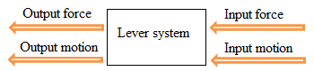  Mechanical Advantage (MA) and Force Multiplier (FM)  FM=MA = load  Effort  Velocity Ratio (V.R) = Movement- Multiplier Ration  MMR=V.R = Distance moved by the effort  Distance moved by the load  EFFICIENCY.  Efficiency = Output x 100% =Work outx 100%=MA 𝑥 100%  Input Woerk in V.R  EXAMPLE 1  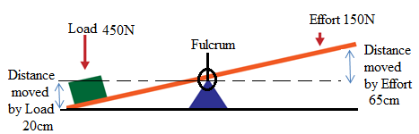  - Find the force-multiplier ratio of the lever system  - Calculate the movement-multiplier ratio of the lever  - Calculate the efficiency of the system  Solution 1  450  a. FM=MA = = 3  150  Distance moved by the effort 65  b. MMR=V.R = = = 3.25  Distance moved by the load 20  c. Efficiency =MA/VR=FM/MMR= 3/3.25 X100 = 92%
Applic ation | CLASS EXERCISE (G9, PAGE 59)  - Find the force-multiplier ratio of the lever system  - Calculate the movement-multiplier ratio of the lever  - Calculate the efficiency of the system | Questions And Answers | Provide answers
Concl usion | - Recap on the main steps and points | V/E

TEACHER: MWALE CHI
DESIGN AND TECHNOLOGY DEPARTMENT
LESSON PLAN

SUBJECT: DESIGN AND TECHNOLOGY CLASS:…… … DATE:……/……./20…. DURATION:………….
BOYS:…………………… GIRLS ………………………………………. TOTAL OF PUPILS…
TOPIC: MECHANISMS SUBTOPIC: LEVERS
LEARNING OUTCOMES LSBAT
- Explain types of mechanisms
- Explain the efficiency, mechanical advantage movement-multiplier and velocity ratio
- Identify and explain three classes of levers
RATIONALE
Knowledge: Types of mechanisms, levers, linkages, input and output movements, functions of mechanisms
Skills: Identification, design, drawing interpretation
Values: Problem solving, Team work
TEACHING AIDS
PART | LESSON CONTENT | METHOD OLOGY | LEARNER ACTIVITY
Introd uction | - Recap on the previous lesson | Questions and answers | Provide answers
Develo pment | MECHANISMS  LEVER  - A lever is a rigid bar resting on a pivot(Fulcrum), used to move a heavy  - A lever system Changes an input force and an input motion into an output force and output motion  TYPES OF CLASSES FIRST CLASS LEVER  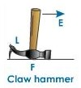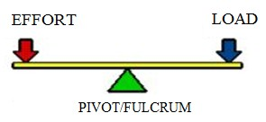  - The fulcrum is between effort and load and effort moves farther than load  - The movement of the load is in the opposite direction of the movement of the effort  - Examples claw hammer, Catapult, Scissors, Pair of pliers, tin opener, crowbar  SECOND CLASS LEVER  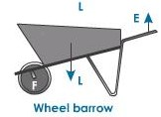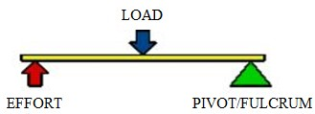  - Load between the effort and the fulcrum.  - The movement of the load is in the same direction as that of the effort  - Examples Wheelbarrow, Nut cracker, Bottle opener  THIRD CLASS LEVER  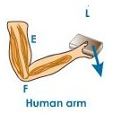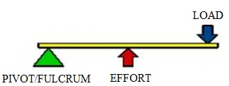  - The effort between the load and the fulcrum.  - Both the effort and load are in the same direction  - Examples Tweezers, Stapler , Mousetrap , Broom, human arms, fishing rod
Application | CLASS EXERCISE  Identify five types of mechanism  Explain and state the examples of the following class levers  - First class lever  - Second class lever  - Third class lever | Questions And Answers | Provide answers
Conclu sion | - Recap on the main steps and points | V/E

TEACHER: MWALE CHI
DESIGN AND TECHNOLOGY DEPARTMENT
LESSON PLAN

SUBJECT: DESIGN AND TECHNOLOGY CLASS:…… … DATE:……/……./20…. DURATION:………….
BOYS:…………………… GIRLS ………………………………………. TOTAL OF PUPILS…
TOPIC: MECHANISMS SUBTOPIC: WHEEL AND AXLE, INCLINED PLANE, WEDGE AND SCREW JACK
LEARNING OUTCOMES LSBAT
- Explain the following mechanisms : Wheel And Axle, Inclined Plane, Wedge and Screw Jack
RATIONALE
Knowledge: Wheel And Axle, Inclined Plane, Wedge and Screw Jack
Skills: Identification, design, drawing interpretation Values: Problem solving, Team work TEACHING AIDS
PART | LESSON CONTENT |  | METHOD OLOGY | LEARNER ACTIVITY
introdu ction | - Recap on the previous lesson |  | Questions and answers | Provide answers
Development | MECHANISMS |  | Questions And Answers  Demonstrat ion  V/E | Taking note of important points  Provide answers
Development | INCLINED PLANE  - Inclined plane is the flat surface that is higher on one end  - Make the work of moving things easier  - Gentle slope means less force needed but more distance will be covered  - Steep slope means more force needed but shorter distance covered  - Mechanical advantage = Distance/ Height | 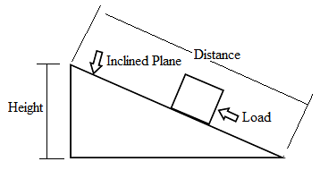Used in real life applications to make moving heavy or delicate objects easier. | Questions And Answers  Demonstrat ion  V/E | Taking note of important points  Provide answers
Development | WEDGE  - Two inclined planes joined back to back.  - A piece of wood or metal that is thinner at one end.  - Examples, knife, an axe  - Wedges are used to split things  - MA= slope/thickness=S/T | 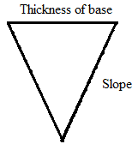 | Questions And Answers  Demonstrat ion  V/E | Taking note of important points  Provide answers
Development | WHEEL AND AXLE  - The wheel and axle consists of a wheel attached to a smaller axle so that these two parts rotate together in which a force is transferred from one to the other  - The Force is applied to the Wheel  Example ,  - screwdriver is an example of a wheel and axle | - Doorknob  - windlass  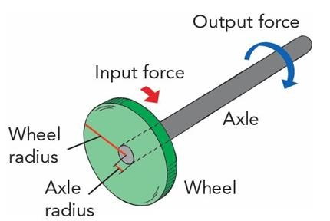 | Questions And Answers  Demonstrat ion  V/E | Taking note of important points  Provide answers
Development | - The handle is the wheel where the force is applied.  - It turns or spins and increases the force of the shaft or axle, which helps turn the screw.  SCREW JACK  - A simple machine that is used for lifting heavy objects by application of a quite small effort.  - They are commonly used with cars |  | Questions And Answers  Demonstrat ion  V/E | Taking note of important points  Provide answers
Applicat ion | CLASS EXERCISE  - Explain the following mechanisms : Wheel And Axle, Inclined Plane, Wedge and Screw Jack  - Give examples wheel and axle. |  | Questions And Answers | Provide answers
Conclus ion | - Recap on the main steps and points |  | V/E

TEACHER: MWALE CHI

DESIGN AND TECHNOLOGY DEPARTMENT
LESSON PLAN

SUBJECT: DESIGN AND TECHNOLOGY CLASS:…… … DATE:……/……./20…. DURATION:………….
BOYS:…………………… GIRLS ………………………………………. TOTAL OF PUPILS… TOPIC: MECHANISMS SUBTOPIC: GEARS
LEARNING OUTCOMES LSBAT
- Define gears

Explain reasons for implementing gears into a system
RATIONALE
Knowledge: Gears, types of gears
Skills: Identification, design, drawing interpretation Values: Problem solving, Team work, application of gears TEACHING AIDS
PART | LESSON CONTENT | METHOD OLOGY | LEARNER ACTIVITY
introd uction | - Recap on the previous lesson | Questions and answers | Provide answers
Development | MECHANISMS  GEARS  - Gears are mechanisms that mesh together via teeth and are used to transmit rotary motion from one shaft to another.  - Gears are used to transfer kinetic energy in a rotary motion using levers.  - 'Driver', the gear which is powered' and Driven', the gear that is moved  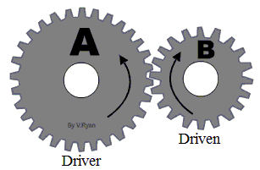  REASONS FOR IMPLEMENTING GEARS INTO A SYSTEM  Change Speed;  - This is achieved by making the number of teeth on each gear different.  - The larger 'Driver' gear has a greater number of teeth than the smaller 'Driven' gear, increasing the number of rotations it makes.  - The difference between each gear is given as a ratio. Driven gear teeth ÷ Driver gear teeth = Ratio  Change Force;  - If the 'Driver' gear is smaller than the 'Driven' gear the speed of rotation is decreased, however, the force applied is increased.  Change Direction of Force;  - When two gears engage the direction of force is reversed as one pushes the other away.  NOTE  LITTLE EFFORT TO MOVE LARGE LOAD  - The driving wheel is smaller than the driven wheel  - The wheel must turn at allow speed MUCH EFFORT TO MOVE SMAAL LOAD  - The driving wheel is larger than the driven wheel  - The wheel must turn at high speed
Appli catio  n | CLASS EXERCISE  - Define gears  - Explain three reasons for implementing gears into a system | Questions And Answers | Provide answers
Concl usion | - Recap on the main steps and points | V/E

TEACHER: MWALE CHI
DESIGN AND TECHNOLOGY DEPARTMENT
LESSON PLAN

SUBJECT: DESIGN AND TECHNOLOGY CLASS:…… … DATE:……/……./20…. DURATION:………….
BOYS:…………………… GIRLS ………………………………………. TOTAL OF PUPILS… TOPIC: MECHANISMS SUBTOPIC: GEARS
LEARNING OUTCOMES LSBAT
- Explain different types of gears
RATIONALE
Knowledge: Gears, types of gears
Skills: Identification, design, drawing interpretation Values: Problem solving, Team work, application of gears TEACHING AIDS
PART | LESSON CONTENT |  | METHOD OLOGY | LEARNER ACTIVITY
introdu ction | - Recap on the previous lesson |  | Questions and answers | Provide answers
Development | MECHANISMS TYPES OF GEARS
Development | 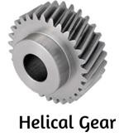  - Helical gears are inclined teeth which have inclined contact to the face of the tooth.  - These gears can carry heavy loads easily.  - This is mostly used at heavyweights at a lower. | 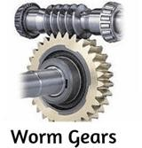  - Used to transmit the power where non- parallel shafts and non-intersecting shafts are present.  Types of worm gears  - Straight Face Worm Gear  - Concave face worm gear
Development | 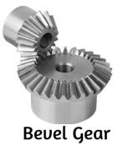  These are commonly found in a hand drill as a way of transferring the users downward rotary motion to lateral motion at the chuck | 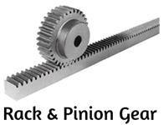  - Rack used to move on the pinion according to the movement applied.  - This type of mechanism used in the steering system.
Development |   - They are simple to manufacture, low cost and easy to maintain.  - Often they are used for low speed applications | 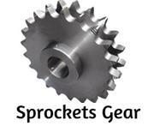  Sprockets gears are mostly used in bikes to drive the chain / belt system for rotational purpose.
Appli cation | CLASS EXERCISE  8. explain any four types of gears |  | Questions And Answers | Provide answers
Conclu sion | - Recap on the main steps and points |  | V/E

TEACHER: MWALE CHI

DESIGN AND TECHNOLOGY DEPARTMENT
LESSON PLAN

SUBJECT: DESIGN AND TECHNOLOGY CLASS:…… … DATE:……/……./20…. DURATION:………….
BOYS:…………………… GIRLS ………………………………………. TOTAL OF PUPILS… TOPIC: MECHANISMS SUBTOPIC: PULLEYS LEARNING OUTCOMES LSBAT
- Define pulley
- Identify and Explain different types pulleys.
RATIONALE
Knowledge: Types of pulleys, mechanical advantage

Skills: Identification, design, drawing interpretation
Values: Problem solving, Team work
TEACHING AIDS
PART | LESSON CONTENT |  | METHODO LOGY | LEARNER ACTIVITY
Introd uction | - Recap on the previous lesson |  | Questions and answers | Provide answers
Develo pment | PULLEYS  - A pulley is a mechanical device that can be used to lift heavily objects more easily.  - A pulley needs a rope, chain or belt around the groove to make it work  - The wheel and axle of a pulley makes it easier to lift heavy objects with the rope.  Mechanical advantage  - Refers to the force needed to move a load divided by the resistance force that the load exerts, such as its weight.  TYPES OF PULLEYS
Develo pment | FIXED PULLEY  - Its changes direction of the force  - Does not change the amount of force applied.  - It does not make the object feel lighter; it only makes it easier to lift.  - Mechanical advantage =1  - A good example of a fixed pulley is a flag pole: | 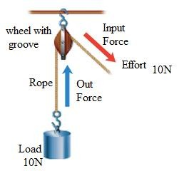
Develo pment | SINGLE MOVABLE PULLEY  - It does not change the direction of the force  - It makes the object feel lighter because less force is required to lift it.  - Mechanical advantage =2  - For example 20N load could be lifted with just 10N of input force.  - Examples of movable pulleys include construction cranes, modern elevator. | 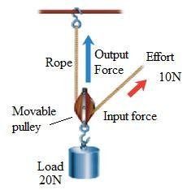
Applicati on | CLASS EXERCISE  Explain the following pulleys  - Fixed Pulley  - Single Movable Pulley |  | Questions And Answers | Provide answers
Conclu sion | - Recap on the main steps and points |  | V/E

TEACHER: MWALE CHI

DESIGN AND TECHNOLOGY DEPARTMENT
LESSON PLAN

SUBJECT: DESIGN AND TECHNOLOGY CLASS:…… … DATE:……/……./20…. DURATION:………….
BOYS:…………………… GIRLS ………………………………………. TOTAL OF PUPILS… TOPIC: MECHANISMS SUBTOPIC: PULLEYS LEARNING OUTCOMES LSBAT
- Identify and Explain different types pulleys.
RATIONALE
Knowledge: Types of pulleys, mechanical advantage

Skills: Identification, design, drawing interpretation
Values: Problem solving, Team work
TEACHING AIDS
PART | LESSON CONTENT |  | METHOD OLOGY | LEARNER ACTIVITY
Introd uction | - Recap on the previous lesson |  | Q/A | Provide answers
Development | COMPOUND PULLEY,  - Consists of combinations of fixed and movable pulleys.  - The movable pulley helps to reduce the force required to lift the object  - The fixed pulley allows you to apply the force by pulling down instead of up.  - Mechanical advantage =3 | 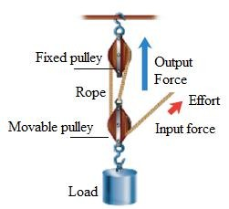
Development | BLOCK AND TACKLE  - Consist of two or more pulleys with a rope between them, usually used to lift heavy loads.  - Mechanical advantage = 3  - Higher mechanical advantage means that less effort is required to move the same load | 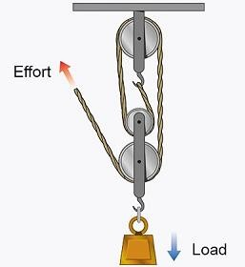
Development | NOTE  TO CALCULATE THE MECHANICAL ADVANTAGE OF A PULLEY  - Count the number of rope sections that support whatever object you are lifting (not counting the rope that is attached to the effort)  - To calculate the effort required to lift the load we divide the load by the number of ropes (do not count the rope that goes to the effort).  - MA= load/effort OR number of rope sections    APPLICATIONS OF PULLEYS  - Use to lift water from the well by making use of pulley  - Use to raise the flag to its pole.  - Used in lifting the cars where counterweight is used to balance the weight of the car.  - Pulleys is used in vehicles to increase their power and make them run more smoothly
Applicati on | CLASS EXERCISE  Explain the following pulleys  - Block And Tackle Pulley  - Compound Pulley, |  | Questions And Answers | Provide answers
Concl usion | - Recap on the main steps and points |  | V/E

